Toys 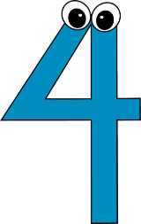 Kids
A program that provides a Christmas Spectacular Event for low income children since 2005.
This event consists of:
- Meet & Greet Santa
- 18 character show including: Mickey & Minnie Mouse, Olaf, Sponge Bob, Frosty The Snowman, Rudolph, and many many more.
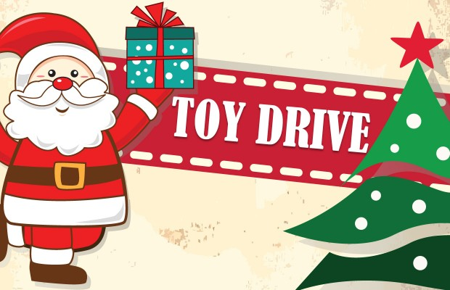
- Magic Show
- Face Painting
- Arcade Games
- Refreshments
- Receiving Toys

If you really want to see and make sure your toy donation goes to less fortunate kids, then I promise this would be your best choice for your toy donation. See our short video of the event that takes place for kids on our web site, www.Rcsprograms.org
We will not just collect toys for our 1,000 children event….but we will intelligently distribute all the extra toys collected to other organization that always hope for toys but never get it.
More information about this or to volunteer at the event please email to Info@rcsprograms.org
The 11th Annual Operation Christmas Smiles event will take place on Sat. December 17th

Toys can be dropped off at our facility 7708 New Utrecht Avenue Brooklyn NY 11214
Larger toy drives can be picked up by our organization.
For more Information call: 917-509-9055

