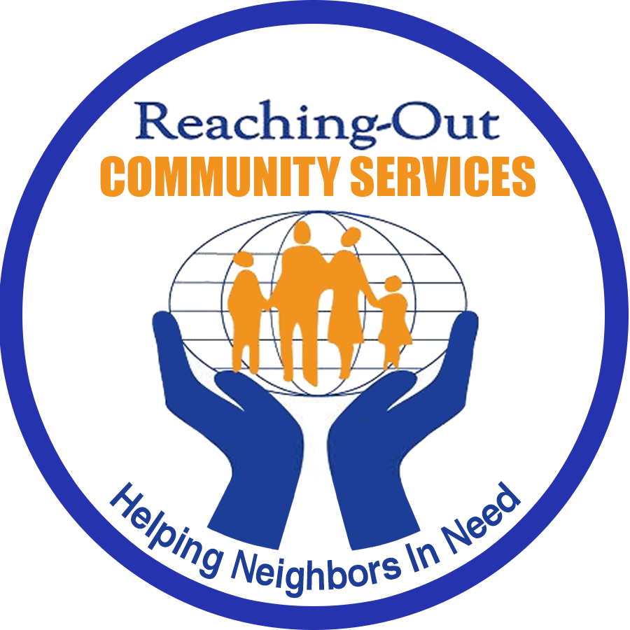
Ticket Order Form
10th Annual Dinner Event

Brooklyn’s Fight Against Hunger

Thursday, April 11, 2019 from 6 – 10PM

Rex Manor
1100 60th Street
Brooklyn, NY 11219

Name: Company: Street Address: _ City: _
Zip: _ Phone: Ext: _ Please provide email for Receipts & Tickets
  - ail: _
(PLEASE PRINT CLEARLY)
Tickets $100 each
Discounted Table of 10 for $925
Enclosed is $ for # ____________Tickets and/or Full Page ____ Half Page ____Journal Ad
Please make checks payable to:
Reaching-Out Community Services, Inc.
7708 New Utrecht Avenue, Brooklyn, New York 11214 Phone: 917-509-9055 Email: info@rcsprograms.org Online: www.rcsprograms.org
Facebook: RCS-Reaching-Out Community Services
Proceeds to assist Reaching-Out Community Services (RCS) and its community
programs for financially disadvantaged families, children, seniors and individuals

Journal Adverti sement Order Form

If you are interested in placing a Journal advertisement in our event program please complete the form below:
    - Clearly fill out contact info on Ticket Mail Order Form
    - Select Ad Size below
    - If placing a text only ad, print text below
    - Submit electronic files in doc, pdf or jpg format to: info@ rcsprograms.org with your name and order information
    - Ad is accepted no later than Tuesday,
April 2nd

Payment in full is required before placement of Ad
Please select Ad Size:
[ ] Full Page ....$125.00 [ ] Half Page ....$75.00

Enter Text Here / Attach Business Card

Call 917-509-9055 to further discuss
Gold or Silver Event Sponsor Opportunities

