Your Name here
------------------------Toys  Kids
“OPERATION CHRISTMAS SMILES”
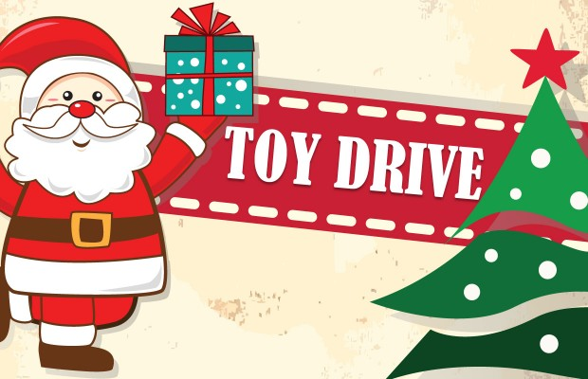

The goal of this Toy Drive is to ensure that every child in our community of low-income status will receive a Christmas gift this holiday season. Each year, this event has been very successful and has lightened up the holiday mood in an economic downturn.

Drop off at
Reaching-Out Community Services, Inc.
7708 New Utrecht Avenue. Brooklyn, NY 11214
Hrs: Mon-Fri. 9 am to 5 pm
Saturday 11 am to 2 pm

For More Information Call: 917-509-9055
Visit our Website @ www.rcsprograms.org
Email Comments: info@rcsprograms.org

