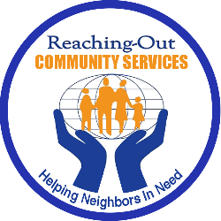
Reaching-Out Community Services
Food Pantry Plus Program
Helping Our Neighbors in Need
OPERATION GOBBLER GIVING

Reaching-Out will provide a turkey and food items on
Monday, November 23, 2020 @ 12:30pm.

Please use this link to visit our website for more information
www.Rcsprograms.org
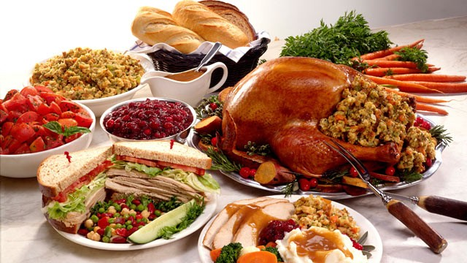

Thanks for Caring & Helping Neighbors in Need!
SPONSOR A FAMILY FOR ONLY $20.00
TO PROVIDE A TURKEY & ALL THE TRIMMINGS.
Please call to make a donation by credit card:
Donation Line @ 917-509-9055
or
Make checks payable to: Reaching-Out Community Services
Mail to:
7708 New Utrecht Avenue, Brooklyn, NY 11214

