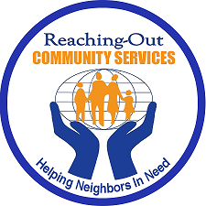
Reaching-Out Community Services, Inc.
7708 New Utrecht Avenue, Brooklyn, NY 11214
Telephone: (718) 373-4565 ext. 110
www.rcsprograms.org
services2@rcsprograms.org

SOCIAL SERVICES AVAILABLE

- SNAP- New Applications and Re-Certifications processed onsite and virtually

- Food Pantry – Digital “Client Choice Food Pantry” allows clients to choose their items catering to allergy, religious and dietary restrictions

- Mobile Food Pantry- Brings our pantry to the homebound and homeless to allow for nutritional food sustenance to those who have limited access

- Free Tax Assistance – During Tax season RCS provides free tax preparation too low to moderate income New Yorkers. ITIN application prep is available during this period as well

- Mental Health Counseling – RCS provides onsite and virtual Mental Health referrals for all types of mental health needs

- Immigrant Legal Services- In conjunction with MOIA, RCS is able to provide the community with a variety of immigrant legal services. Citizenship classes are available through this program

- Housing Subsidies- RCS participates in numerous programs to assist the community in rental arrears, eviction prevention and obtaining senior housing

- Job Training Programs- Reaching Out has Job Training Programs and placement assistance, tuition is free to those who qualify

- Adult Online Learning – RCS has various online Adult Learning Programs such as ESL, Basic ED & High School Diploma this program is free to any NY resident over 21 Yrs of age

** The Food Program is limited to Brooklyn area zip codes; all other programs are available to the 5 Boroughs of NYC**

