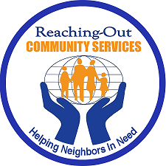
Operation Backpack & Supplies Event
SPONSORSHIP FORM
Date: Saturday, August 27, 2022 from 12 PM - 2 PM
Location: 7708 New Utrecht Avenue Brooklyn, NY 11214
Your Company's support for this event is an important component of our success and is greatly appreciated. A representative will be happy to answer any questions you may have and can discuss any aspect of your participation. Please contact Thomas Neve at 917-509-9055 or email to: tomneve@rcsprograms.org
Yes! I want to help Reaching-Out Community Services, Inc. and know that my support will have a positive impact!
Company Name:
Address:
City, State & ZIP:
Web site address:
Contribution: | $
Contact Name & Title:
Phone:
Email:

You may email form to: tomneve@rcsprograms.org
Please return the above information with a check made payable to:
Reaching-Out Community Services, Inc.
7708 New Utrecht Avenue Brooklyn, NY 11214
(718) 373-4565
www.rcsprograms.org

